| PROJECT INFORMATION | | | |
| --- | --- | --- | --- |
| **Report Description:** | Feature Extraction | | |
| **Professor:** | Prof. [Gady Agam](mailto:agam@iit.edu) | **Tools used/work done:** | 1. Augmentation 2. Feature Extraction and training |
| **Report prepared by:** | [Noviya Balasubramanian](mailto:nbalasubramanian@hawk.iit.edu) |
| **HAWK ID:** | A20541236 |
| **Report no:** | 14 | **Report Date:** | 11/22/2024 |

**Timeline:**

1. **First 6 Weeks: Literature Review, Data Access, Preprocessing, Problem Statement Definition**
2. **Week 7 (Oct 4): Data Preprocessing Completion, MARA Exploration in MATLAB - Completed for 33 subjects**
3. **Week 8 (Oct 11): Labeling, Feature Extraction and Classification - Initial Training**
4. **Week 9 (Oct 18): Classifier Selection and Initial Training - Feature extraction**
5. **Week 10 (Oct 25): Classifier Optimization and Validation - [**[**Worked in Augmentation**](https://colab.research.google.com/drive/1u_p-kIBw7xU9kgNdWy27XNOM-br_-Ia7?authuser=4#scrollTo=6rUZ1Dl13Heu)**]**
6. **Week 11 (Nov 1): ~~Multimodal Analysis~~ - Did CNN Classifier**
7. **Week 12 (Nov 8): Fusion or Comparison Analysis Scope**
8. **Week 13 (Nov 15): Final Testing**
9. **Week 14 (Nov 22): ~~Model Evaluation~~ - Did Binary classification**
10. Week 15 (Nov 29): Report Preparation (Buffer)
11. Week 16 (Dec 6): Report Submission

**Topic: Classification of Cognitive States Using EEG and Physiological Signals: Impasse, Aha!, Uncertainty**

- **Total Labels Loaded**: 910, 1s Window size

**Before Augmentation:** Total Segments: 910; Shape of Segments: (125, 16)

Total Labels: 910

Label Counts: Walking: 290; Aha: 290; Doing Other Task: 290; Re-evaluation: 25; **Impasse: 43**

Gaussian noise is added to the original segments, generating new samples that mimic the statistical properties of the existing data. This noise is produced using a normal distribution with a 0 mean and 0.05 standard deviation, ensuring the augmented data retains its underlying characteristics.

**After Augmentation:** Total Segments: 1450; Shape of Segments: (125, 16)

Total Labels: 1450

New Label Counts: Walking: 290; Aha: 290; Doing Other Task: 290; Impasse: 290; Re-evaluation: 290

Added Standard deviation - 0.05

My approach **Spatio-Temporal FNet**:

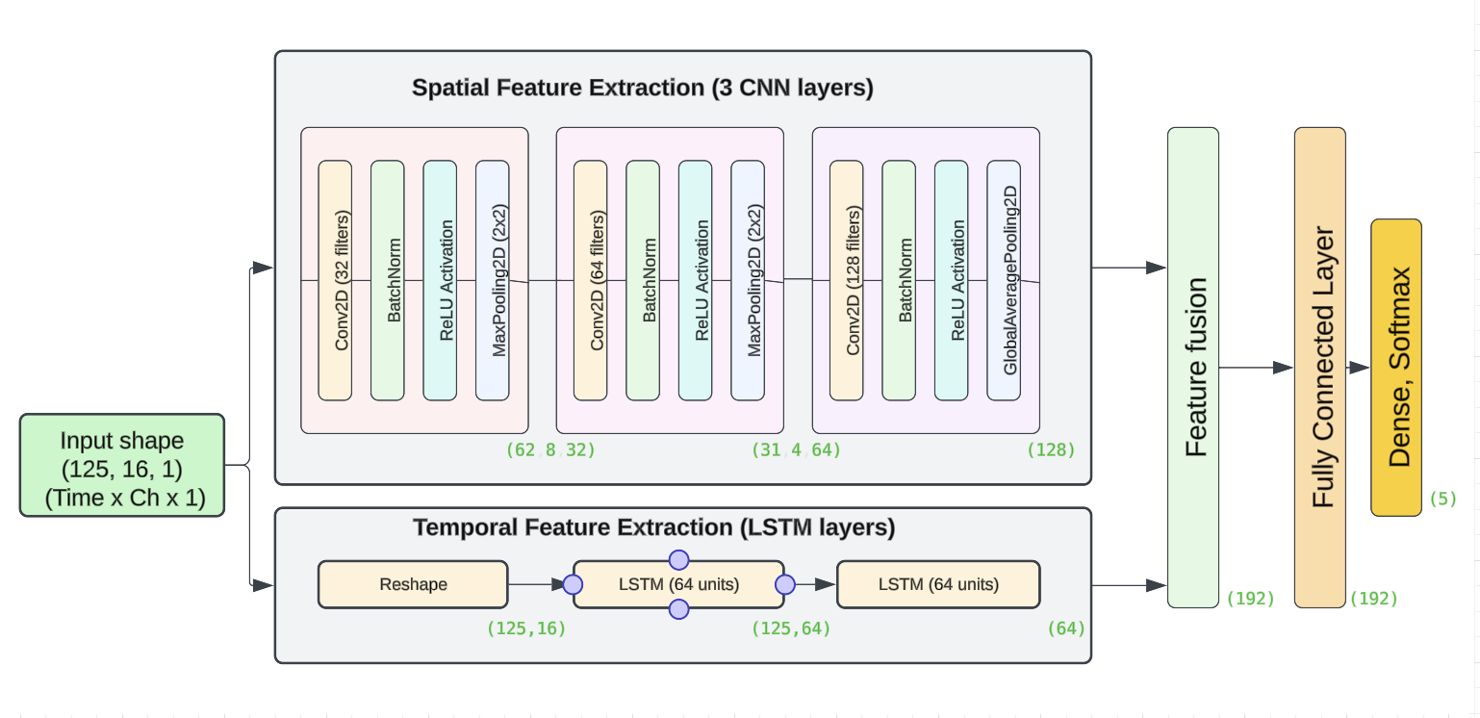

**Fused features - Spatio-Temporal FNet - 5 class:**

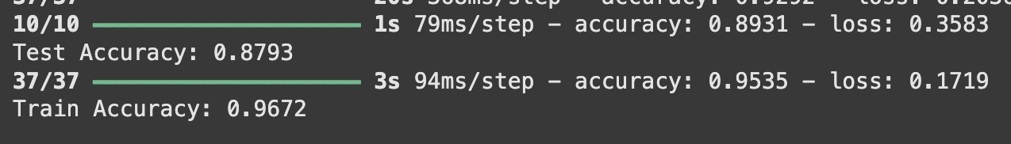

**Fused features - Spatio-Temporal FNet - binary classification:**

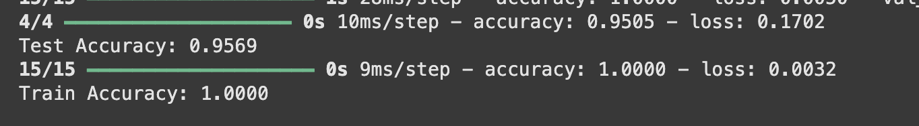

**Aha vs Impasse:Label Mapping: {0: 'Aha', 1: 'Not Aha'}  
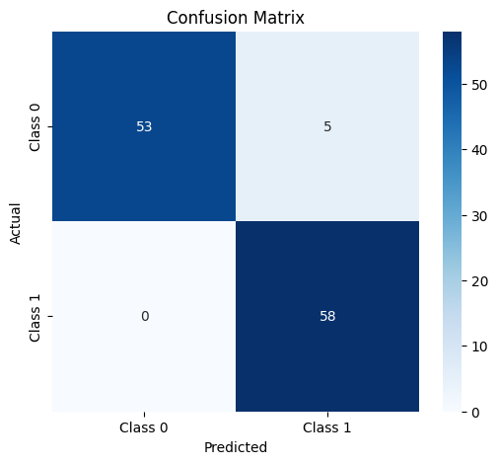**

**Tsception Model:**

**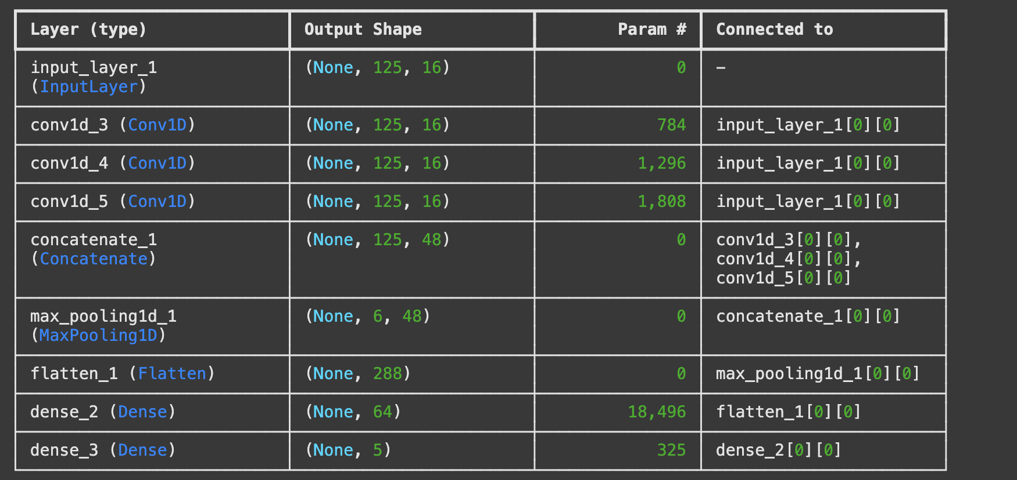  
5 class classification:**

**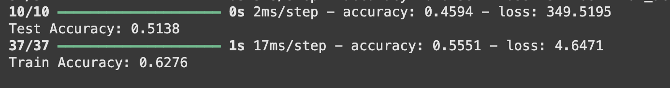  
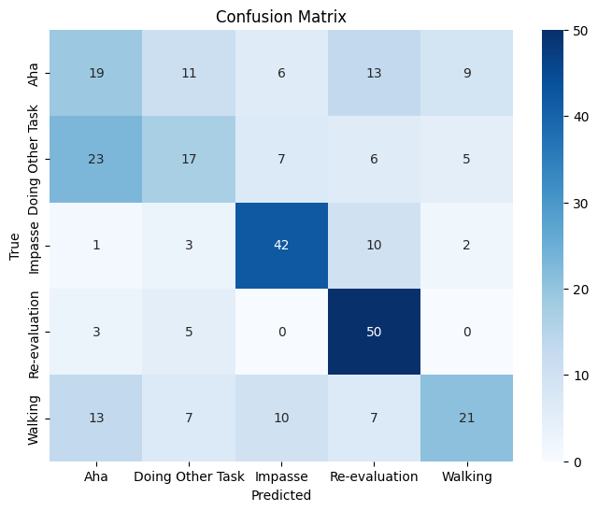**

**Binary classification:**

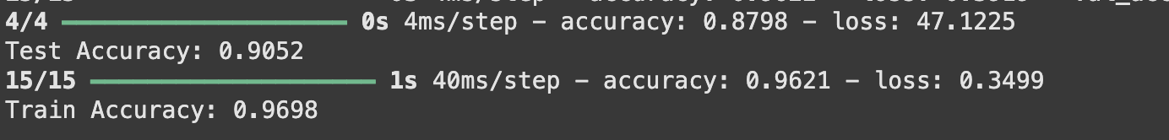

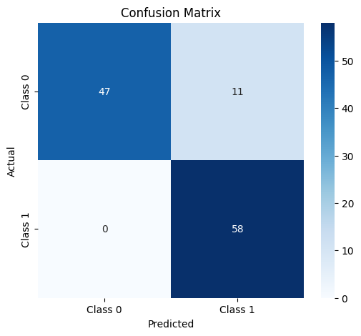

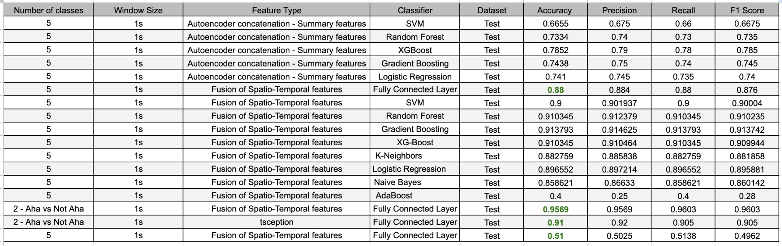

* **Split the data same as Xiaoting**
* **Binary -**>> Aha vs not - AHa>> Impasse vs not - Impasse>> Attention vs not
* **Don't use same person’s data in both training and testing**
* **Cross validation**
* **Include other time window size - 3s, 5s**
* **Take different removal degrees of 1s frame**
* 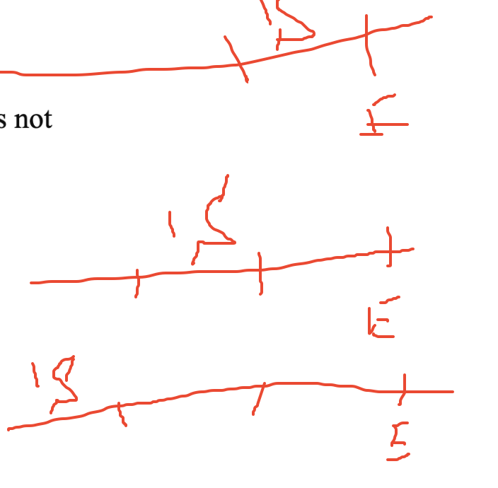

Todo:

1. Improve augmentation -
2. Improve labeling
3. Combine the tables
4. Get labels from Xiaoting - compare -

>> Aha vs not - AHa

>> Impasse vs not - Impasse

>> Attention vs not

Section B time - 3s